Schema code for the website ChinaPCBA:
1. Corporation Schema
<script type="application/ld+json">
{
"@context": "https://schema.org",
"@type": "Corporation",
"name": "China PCB Assembly",
"alternateName": "ChinaPCBA",
"url": "https://www.chinapcbassembly.com/",
"logo": "https://www.chinapcbassembly.com/uploads/library/688b02d2cd550_logo.png"
}
</script>
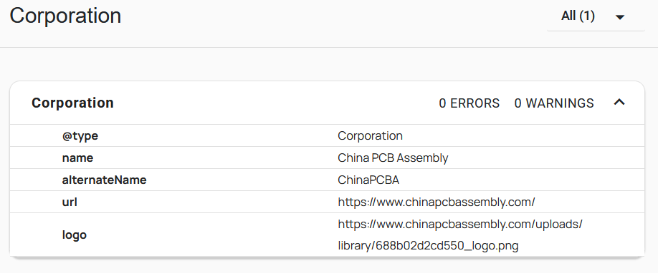
2. Website Schema
<script type="application/ld+json">
{
"@context": "https://schema.org/",
"@type": "WebSite",
"name": "ChinaPCBA",
"url": "https://www.chinapcbassembly.com/",
"potentialAction": {
"@type": "SearchAction",
"target": "{search_term_string}",
"query-input": "required name=search_term_string"
}
}
</script>
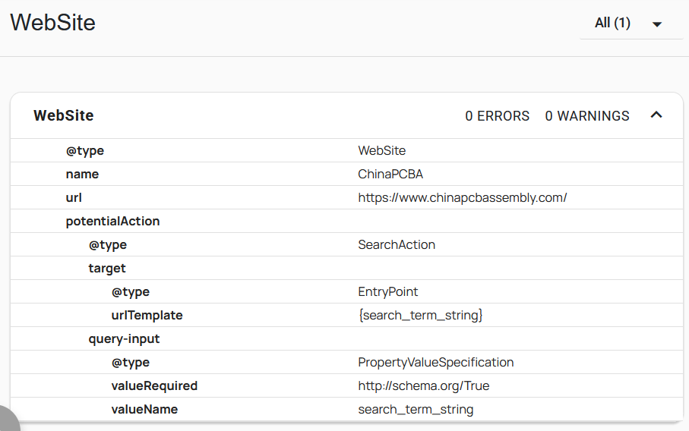

Note: Please replace the value of search box URL and validate with this tool: https://validator.schema.org/
3. Home Page FAQ
<script type="application/ld+json">
{
"@context": "https://schema.org",
"@type": "FAQPage",
"mainEntity": [{
"@type": "Question",
"name": "Are your PCB assembly services RoHS and REACH compliant?",
"acceptedAnswer": {
"@type": "Answer",
"text": "Yes. We only use lead-free assembly in our factory. All the PCBs assembled in our facility meet the requirements of RoHS &amp; REACH. Please check our RoHS and REACH Compliance Declaration at https://www.chinapcbassembly.com/viasionwp/rohs-reach/."
}
},{
"@type": "Question",
"name": "Do you offer engineering support?",
"acceptedAnswer": {
"@type": "Answer",
"text": "Our engineers will conduct thorough DFA(Design for Assembly) checks and optimize the design for the best quality, price, and lead time. We can also help update existing designs or create new ones if necessary."
}
},{
"@type": "Question",
"name": "What files does ChinaPCBA need to quote a PCB assembly project?",
"acceptedAnswer": {
"@type": "Answer",
"text": "We need Gerber files (or other formats) for PCB bare boards and BOM (Bill of Material) for the components and assembly. Please contact our sales team if you have any doubts about this."
}
},{
"@type": "Question",
"name": "How can I get a quote?",
"acceptedAnswer": {
"@type": "Answer",
"text": "You may just drop us an email at sales@chinapcbassembly.com or viasion@yahoo.com. You may also contact our sales team: https://www.chinapcbassembly.com/contact-us/."
}
},{
"@type": "Question",
"name": "What is your lead time for PCB assembly service?",
"acceptedAnswer": {
"@type": "Answer",
"text": "The lead time of PCB assembly services depends on which of the services you need:
Turnkey PCB assembly: 3-4 weeks (including components sourcing)
Consignment PCB assembly: 1 week (after component received)
Quick turn PCB assembly: 24 hours (do not include component sourcing time)
Box build assembly: 4-6 weeks.
Please get in touch with our sales team for a free quote right now!"
}
},{
"@type": "Question",
"name": "What is your MOQ (Minimum Order Quantity)?",
"acceptedAnswer": {
"@type": "Answer",
"text": "ChinaPCBA is dedicated to low to medium-volume PCB assembly services. We welcome orders as small as one piece."
}
},{
"@type": "Question",
"name": "How much does a PCB assembly cost?",
"acceptedAnswer": {
"@type": "Answer",
"text": "The cost of PCB assembly varies since they come in various types and with diverse specifications. Prices depend on electronic components, PCB bare boards, PCB assembly technologies (SMT, THT, mixed), order quantities, etc. Please contact us today to get a free quote immediately."
}
},{
"@type": "Question",
"name": "What are your advantages in PCB assembly services?",
"acceptedAnswer": {
"@type": "Answer",
"text": "We have been dedicated to small to medium-batch PCB assembly services since 2007. Our production line and personnel are established to meet his goal. With the support of our reliable supply chain and experienced engineering and production team, we can supply high-quality PCBA services at low cost and with quick delivery, especially in low to medium-volume production."
}
},{
"@type": "Question",
"name": "Does you supply turnkey electronic manufacturing services?",
"acceptedAnswer": {
"@type": "Answer",
"text": "Yes. In addition to PCB assembly, we can supply complete electronics assembly and manufacturing services, including PCB assembly, cable assembly, mechanical assembly, IC programming, final product testing, and labeling."
}
},{
"@type": "Question",
"name": "Can ChinaPCBA help to source all electronic components for us?",
"acceptedAnswer": {
"@type": "Answer",
"text": "Yes. We can supply turnkey PCB assembly services, including PCB fabrication, component sourcing, PCB assembly, and final inspections and testing."
}
}]
}
</script>
